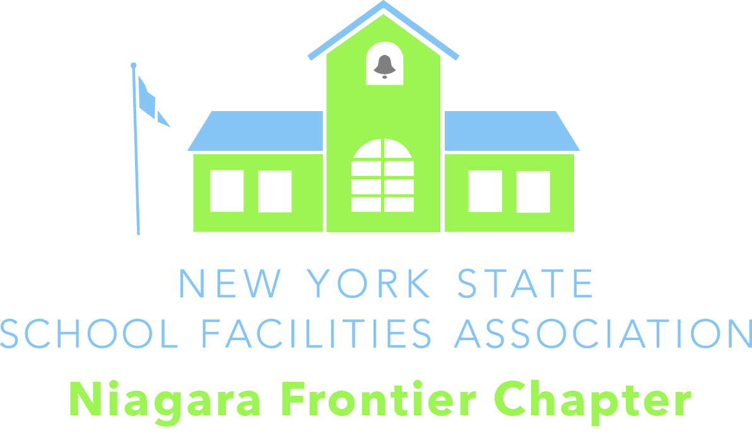

Niagara Frontier Chapter
New York State School Facilities Association
GIVING THE LAMP OF KNOWLEDGE A SAFE PLACE TO SHINE ________________
Mark Rampado Mike Sitzman David Martin Charles Milne Earl Smeal David Cuirczak
President Vice President Treasurer Secretary State Director 1st Vice President
Amherst CSD Eden CSD Retired Eden CSD Newfane CSD Niagara Falls CSD Starpoint CSD
716-362-8151 716-992-3602 716-947-4972 716-998-2759 716-286-4243 716-210-2344

SCHOLARSHIP APPLICATION

We will be awarding a minimum of five (5) $500.00 scholarships to eligible high school seniors. The high school senior must attend a school in Western New York. Preference will be given to students who are enrolling in subjects related to Building Management, Repair, Maintenance, and Design. Students pursuing a career related to the operations, design, or construction of facilities are encouraged to apply. Examples of applicable areas include, but are not limited to: Building Trades, Engineering, Architecture, Landscape Design, etc.

Students wishing to apply for a scholarship must fill out the attached application and return it along with the letters of reference to Mr. Earl Smeal, Niagara Falls City School District, 630 66th Street, Niagara Falls, NY 14304 by MONDAY May 19th, 2025. The Scholarship Committee will then review the applications and notify the scholarship recipients’ school district by June.

The scholarship winners will be presented a certificate of award. The check for the scholarship will be made payable directly to the student after the Scholarship Committee receives verification of registration. This verification could be in the form of a letter from the registrar or a copy of the student’s paid bill. Verification should be sent to David Martin, 6753 Derby Road, Derby NY 14047.

Scholarship Application

(Please print neatly or type. Use additional paper as needed)

Name__________________________________________________

Phone________________________Email________________________________

Address______________________________________________________________________
(Street) (City) (State) (Zip)

School District attending________________________________________________________________

Date of birth____________________________ Rank in class/ Size of class_______________________

Parents’/ Guardians’ names_____________________________________________________________

What is your anticipated area of study_____________________________________________________

Colleges, Universities, Technical Schools to which you have applied_____________________________
________________________________________________________________________________________________________________________________________________________________________

Have you been accepted to any of the above? Yes________ No_______ If yes please list
________________________________________________________________________________________________________________________________________________________________________

Check one ( ) 2 Year program ( ) 4 Year program ( ) other, please explain

What are your immediate career plans? ____________________________________________
_______________________________________________________________________

List all the activities and sports in which you participated______________________________________
____________________________________________________________________________________
____________________________________________________________________________________
____________________________________________________________________________________

List of honors and awards_______________________________________________________________
____________________________________________________________________________________
____________________________________________________________________________________
____________________________________________________________________________________

Have you held any leadership positions? If so, please explain

Scholarship Application (continued)

Community Service___________________________________________________________________
____________________________________________________________________________________
____________________________________________________________________________________

Work Experience___________________________________________________________________________
____________________________________________________________________________________
____________________________________________________________________________________

Hobbies and Special Interests____________________________________________________________
____________________________________________________________________________________
____________________________________________________________________________________

In the space below, write a short autobiography including any unusual, special or family circumstances, which you feel, would be helpful to the Selection Committee. Be sure to include the career path that you are interested in pursuing that fits this scholarship and the reason why you feel that you would be a good candidate for this Scholarship. (Use an additional sheet if needed).
____________________________________________________________________________________
____________________________________________________________________________________
____________________________________________________________________________________
____________________________________________________________________________________
____________________________________________________________________________________
____________________________________________________________________________________
____________________________________________________________________________________
____________________________________________________________________________________
____________________________________________________________________________________
____________________________________________________________________________________
____________________________________________________________________________________
____________________________________________________________________________________
____________________________________________________________________________________
____________________________________________________________________________________
____________________________________________________________________________________
____________________________________________________________________________________
____________________________________________________________________________________
____________________________________________________________________________________
____________________________________________________________________________________
____________________________________________________________________________________

Please enclose two letters of reference (from a non-family member such as Clergy, Teacher, past employer, coach, community leaders etc.) Return the application and letters of reference to: Mr. Earl Smeal, Niagara Falls City School District, 630 66th Street, Niagara Falls, NY 14304

